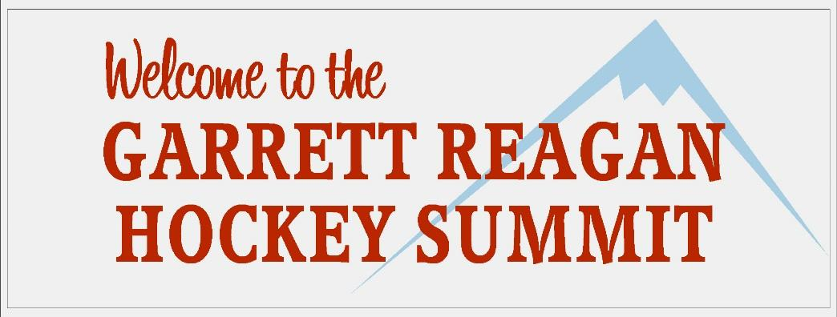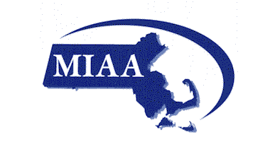

- To: Coaches, Players and Parents
From: Massachusetts State Hockey Coaches Association
Date: May 5, 2021
Re: Garrett Reagan High School Hockey Summit
The Massachusetts State Hockey Coaches Association in association with the Massachusetts Interscholastic Athletic Association presents the twelfth annual Garrett Reagan High School Hockey Summit. The Summit will take place on Sunday, December 5, 2021 at the New England Sports Center. For the past 11 years, seventy teams and over 1,300 players have participated in this one day event. This will be a great kickoff to the 2021-2022 high school hockey season. In addition to playing a mini game (two 15 minute periods), each player/team will participate in workshops coordinated by the Massachusetts State Hockey Coaches Association and the MIAA.

If you have any questions please contact John Maguire at maguirej19@gmail.com.

We look forward to seeing you on December 5th.

&

MASSACHUSETTS STATE HOCKEY COACHES ASSOCIATION PRESENT:

GARRETT REAGAN HIGH SCHOOL HOCKEY SUMMIT
DECEMBER 5, 2021
NEW ENGLAND SPORTS CENTER

LETTER OF COMMITMENT

This letter is to confirm your interest in the GARRETT REAGAN High School Hockey Summit. Please fill out the registration form below. Make sure your athletic director signs this form. The Summit has room for 80 teams – to guarantee a spot please return form and check as soon as possible. Please send the completed form and a check made payable to MSHCA for $175 to the following address: MSHCA, PO Box 550069 North Waltham, MA 02455.

REGISTRATION FORM

School Name: _______________________________________

School Address: ________________________________________

Coach’s Name: ________________________________________

Coach’s Email: ________________________________________

Coach’s Phone: ________________________________________

Coach’s Signature: _________________________________________

AD Signature: _________________________________________

Please contact John Maguire at 781-775-7114 or via email at maguirej19@gmail.com for further information.

